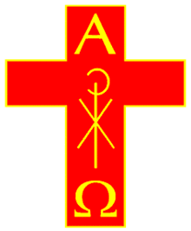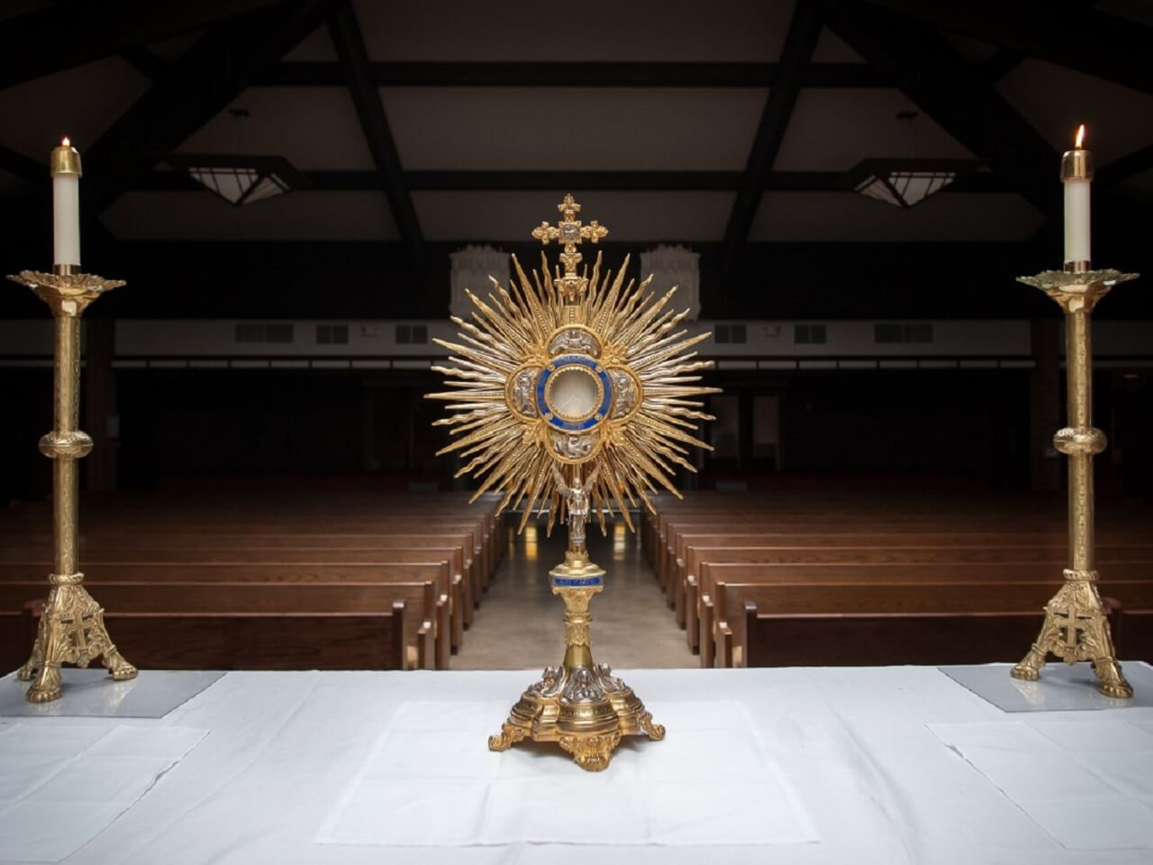

The Society of Catholic Priests

**ADORA E!**

Eucharistic Adoration | Corpus Christi 2019

Date | Time | Church