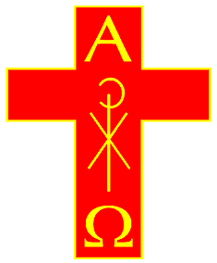

______________________________

was admitted to membership of

The Society of Catholic Priests

in the

______________________________

Chapter

on

______________________________

______________________________
Chapter Rector

M
embers of the Society of Catholic Priests believe that the Churches of the Anglican Communion are part of the One, Holy, Catholic and Apostolic Church, ordaining men and women to serve as Deacons, Priests and Bishops in the Church of God; believe in the real presence of the risen Lord Jesus in the Eucharist; use and practice the seven sacraments of the Church; and undertake to keep the rule of life of the Society.
The Rite of Admission

I accept these precepts.

M
embers of our Society seek to centre their lives on the real presence of Christ in his sacraments; to follow a corporate rule of life with integrity and humility; to give and receive hospitality after the example of Jesus; to seek the peace and unity of Christ’s Church, aspiring to live in full communion with all of the baptized; and to proclaim by word and example the Gospel. Our life together is expressed in the hospitality of our meetings, the concelebration of the Eucharist, mutual pastoral care for each other, and regular prayer for the priestly work of all the brothers and sisters.
The Rite of Admission

I aspire to this way of life.

______________________________
Signature of Member

______________________________
Date

